The University of British Columbia Biometeorology and Soil Physics Group:

Portable CO2 Chamber System

Instruction Manual

Authors: Iain Hawthorne, Katrin Schmid

Table of Contents

Portable Chamber System Consumable Components …………………….…….3

Laboratory System Preparation ………......................................................................3

Start-Up …………………………………………………………………………………………....3

Data Collection ……………………………………………………………………………….…4

Downloading Data ………………………………………………………………………….…5

Organizing Data ………………………………………………………………………………...5

Data Analysis …………………………………………………………………………………….7

Portable Chamber System Consumable Components

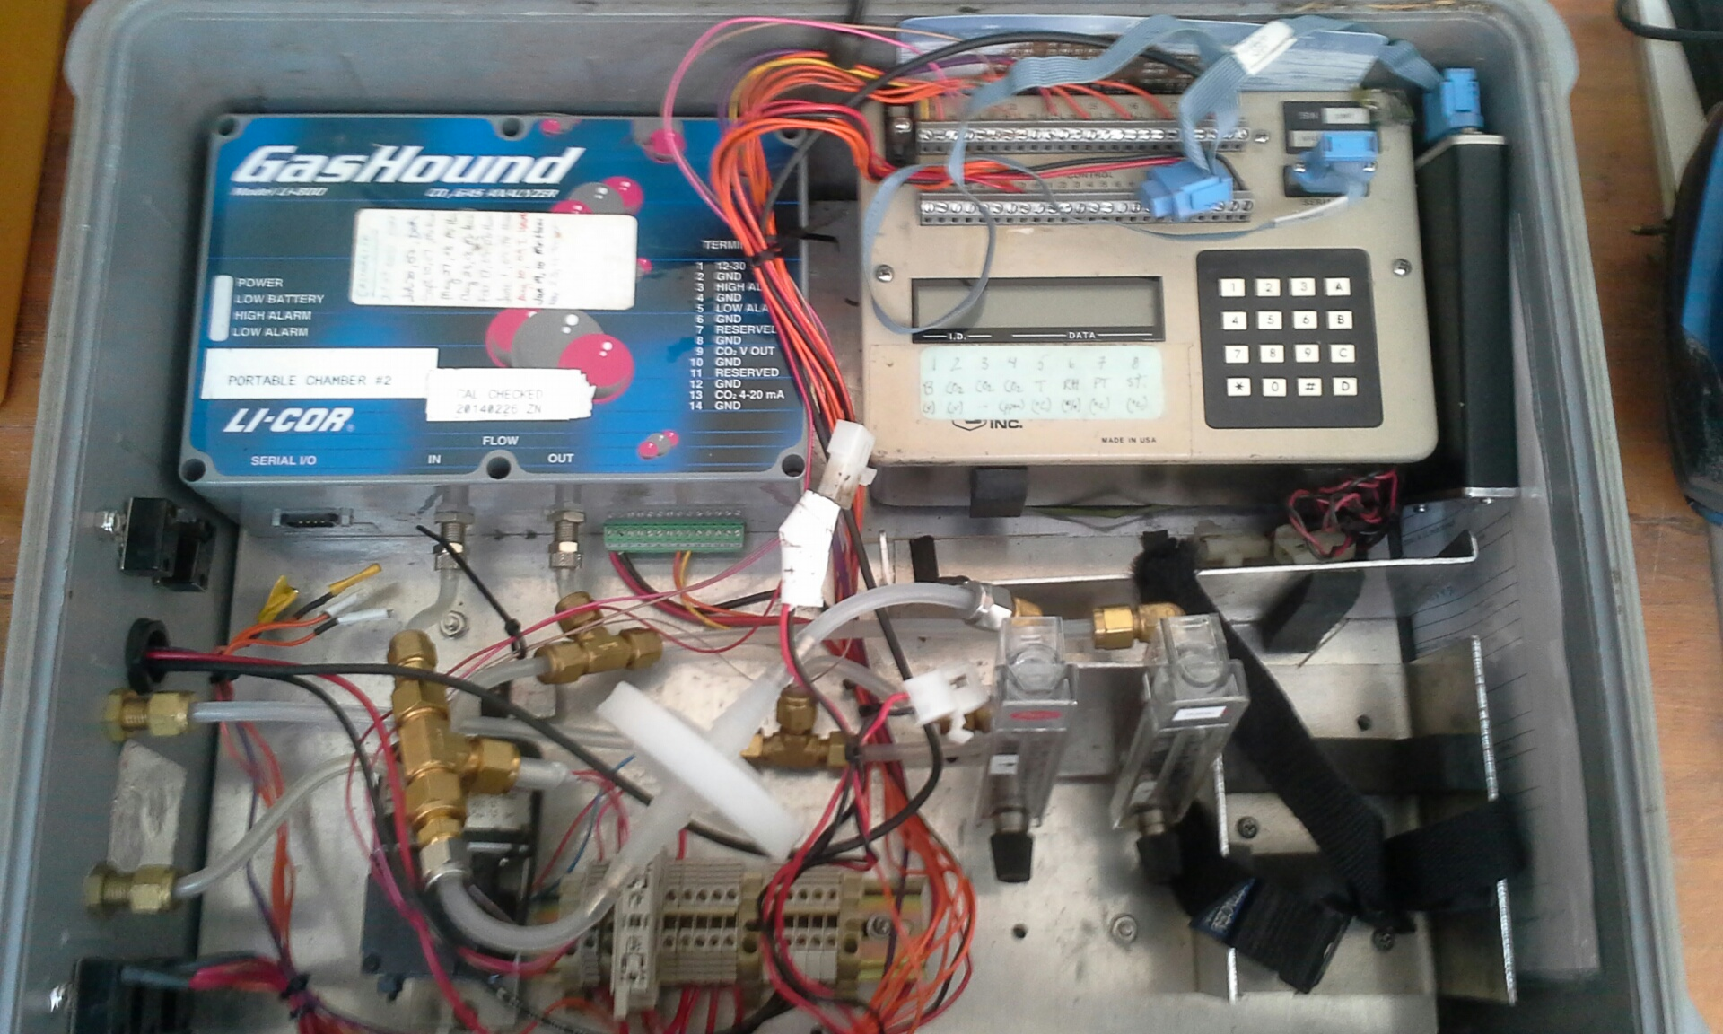-GasHound

-Soil thermocouple

-21x datalogger

-SM4M storage module

-Small pump

-7Ahr gel cell battery

-¼” tubing

-0.7 um filter

-Line plugs for transportation

-Chamber enclosure, connectors and tubing (1/4”)

Laboratory System Preparation

1. Confirm system is available and register your expected usage time with research engineer in Biomet (ezoran.nesic@ubc.ca)
2. Ask engineer about calibration status of system
3. Calibrate if needed
4. Charge sufficient number of gel cell batteries
5. Check status of storage module (storage capacity)

Start-Up

1. Place fully charged small gel cell 12V battery in bottom right corner of Pelican case, plug in using Timaya/standard battery connector. Make sure to secure the battery with the “seatbelt” so it won’t move while being transported.

🡪 Data panel display turns on (“HELLO”)

1. Connect data storage to data panel using thick light blue cable
2. Display panel reads “11” or “130000” 🡪 system ready
3. To enter date and time, press (*) (5), to advance press (A), to return press (B)
4. Length of time system has been running
5. Display reads “05:19” 🡪 set to current year e.g. “05:14”
6. Day of year, e.g. “05:148”
7. Current time, e.g. “05:15:30”
8. Enter (*) (6)
9. 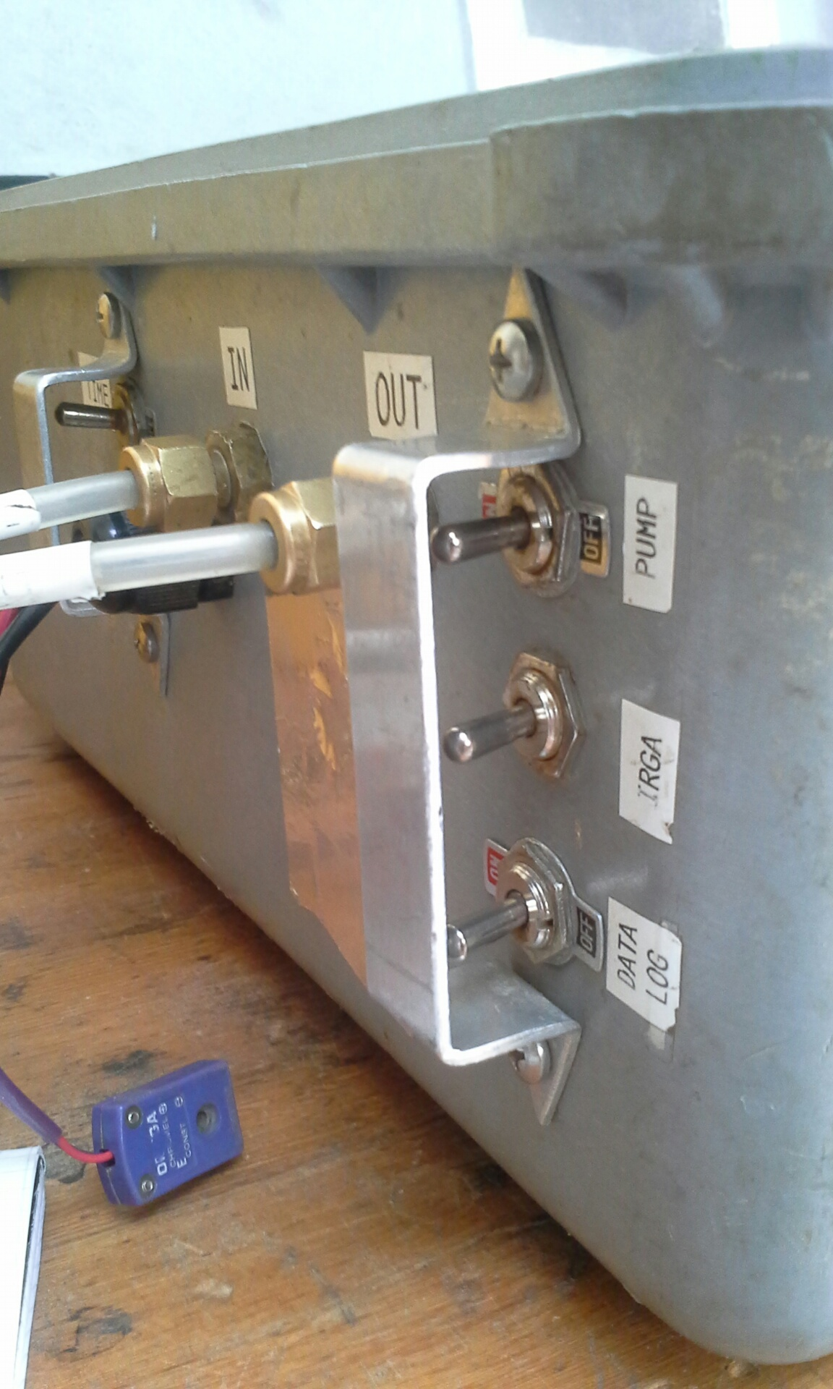Display reads “06:1”, press (A) for current battery voltage (should be around 13v)
10. Turn IRGA switch on left outside of Pelican case to ON 🡪 battery level (*6, Location 1) will sink while GasHound heats itself, this takes ca. 20 minutes
11. Attach portable chamber tubes to Pelican case using connectors on left outside. Make sure to attach chamber’s IN tube to the IN connector on the case, likewise OUT to OUT.

**Do not let dirt and debris enter the flow line for the system. This will clog the lines, creating erroneous readings and costly repair.**

Data Collection

1. Turn data log switch below IRGA switch to ON (if data panel display is flashing, data log has not been turned on)
2. To read data enter (*) (6), then
3. Battery voltage
4. System voltage
5. CO2
6. CO2 in ppm
7. GasHound temperature in degrees Celsius
8. Relative humidity in %
9. Panel temperature in degrees Celsius
10. Soil temperature in degrees Celsius
11. Attach system thermocouple
12. Turn pump ON using flick switch on Pelican case[1]
13. While waiting for CO2 (found under (*, 6, 4, A)) reading to stabilize at background levels (depends on ecosystem being studied) check the system voltage (*, 6, 2, A)
14. While showing CO2 ppm on display panel, flush chamber of remnant CO2 until atmospheric background (usually ca. 400ppm or lower). Avoid breathing into chamber.
15. Turn storage module ON using flick switch on Pelican case (display panel should stop flashing)
16. Attach portable chamber top to chamber collar at site, press down to ensure no air enters chamber from outside while taking the sample
17. Insert thermocouple into soil   
    CAUTION FRAGILE: insert probe carefully into soil while holding top of needle to avoid damage to wires inside

10.) Allow pump to run for around two minutes, note start and end time of ……sampling as well as start and end CO2 ppm values

11.) Turn storage module OFF

12.) Remove chamber top from collar and vent to background

13.) Repeat for other collars

* 1. Pay attention to battery voltage

1. Disconnect battery, external tubing/lid enclosure and thermocouple when finished

Downloading Data

1. Disconnect storage module from data panel and connect to computer  
   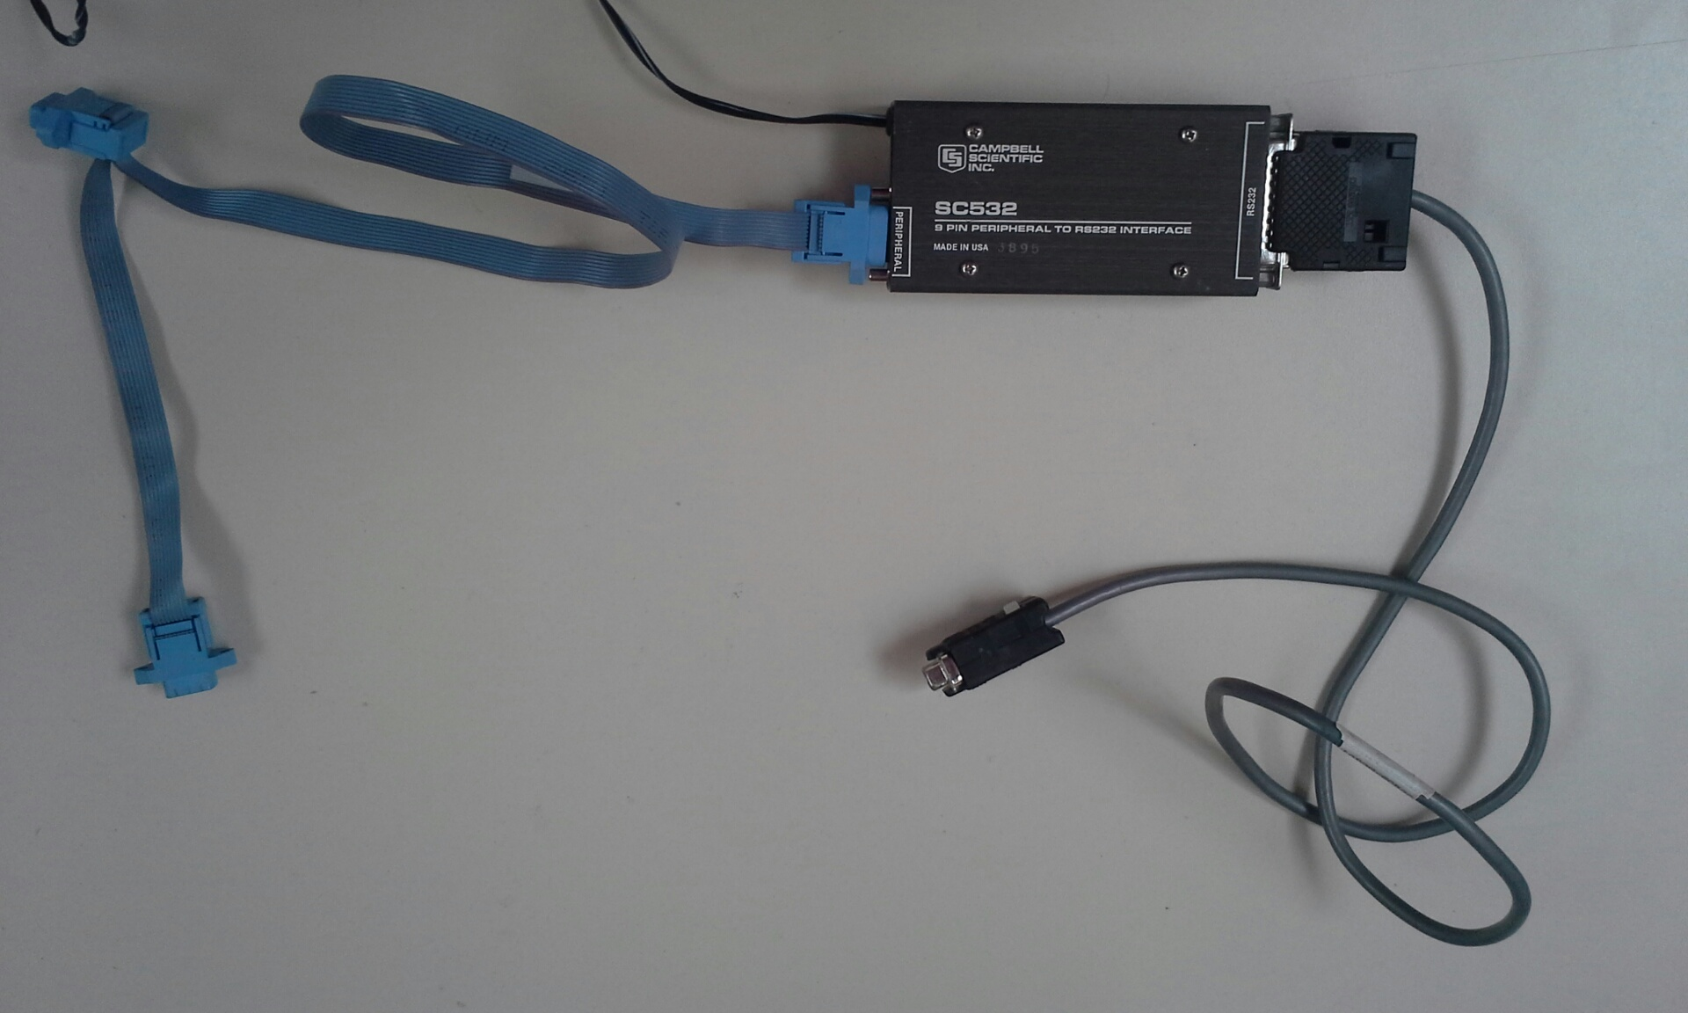
2. Open LoggerNet program 🡪 choose (SMS) on taskbar
3. (SMS) window pops up 🡪 select (SM4M/SM16M)

* File Format: Comma separated
* File Naming: e.g. CO2C-001.dat
* Auto-Increment Name

1. Choose “Connect”
2. First time, for backup: “Get All”

Otherwise: “Get New”

1. When finished downloading: “Disconnect”
2. DO NOT CLEAR PROGRAM
3. Remember to return storage module to Pelican case!
4. Notify technician of ANY problems encountered.

You are 100% responsible for the safe return and operation of the system.

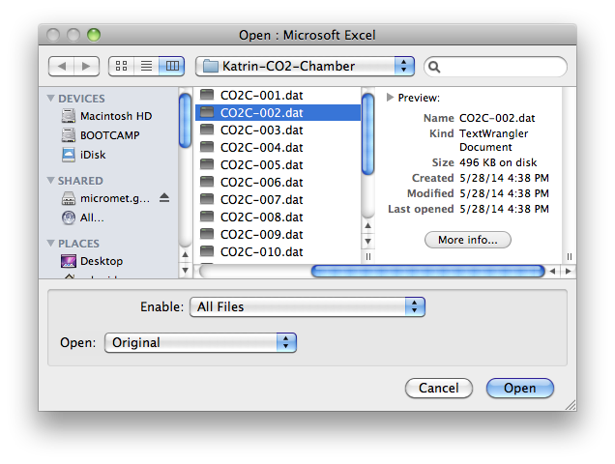Organizing Data

1. Choose file to open with Microsoft Excel. If Excel does not appear in list, make sure you have enabled “All Files”, not only “Recommended Files”
2. Data will appear, separated by comma
3. 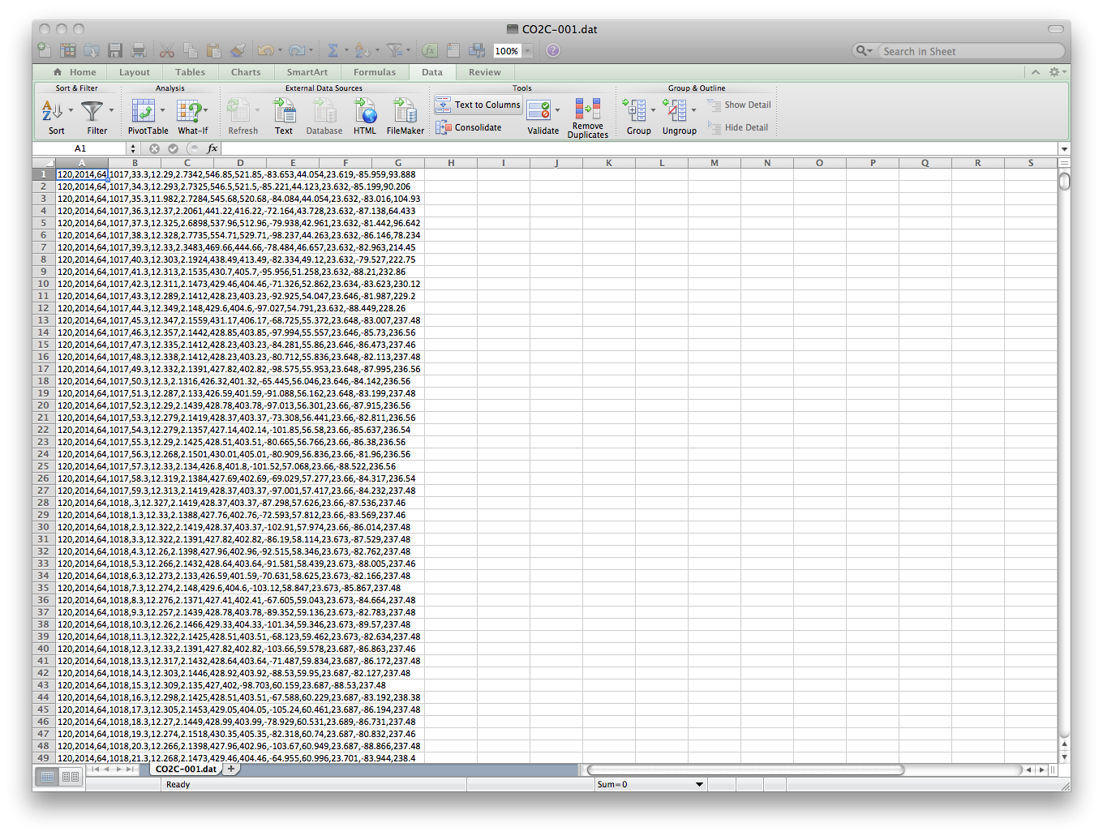Click on “Data”, select the column A, then click “Text to Columns”
4. A new window will pop up. Make sure the file type is set to “Delimited” then click “Next”

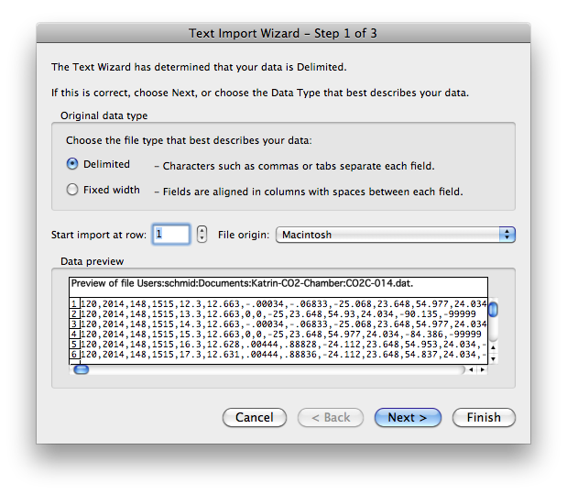

1. Set the Delimiters to “Tabs”, then click “Next”. Step 3 will pop up, click “Finish”

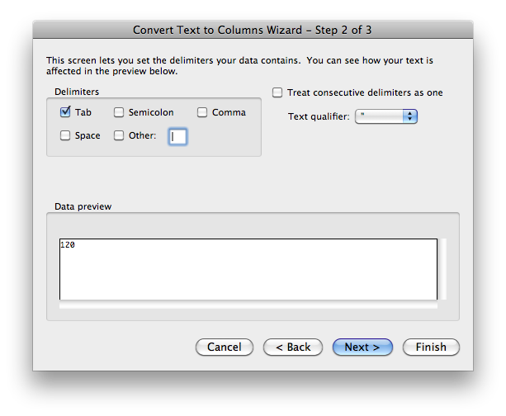

1. To view a chart of CO2 emissions measured, choose column “I”, then click “Charts”
2. Choose your preferred display method e.g. “Lines” 🡪 “Marked Line”
3. 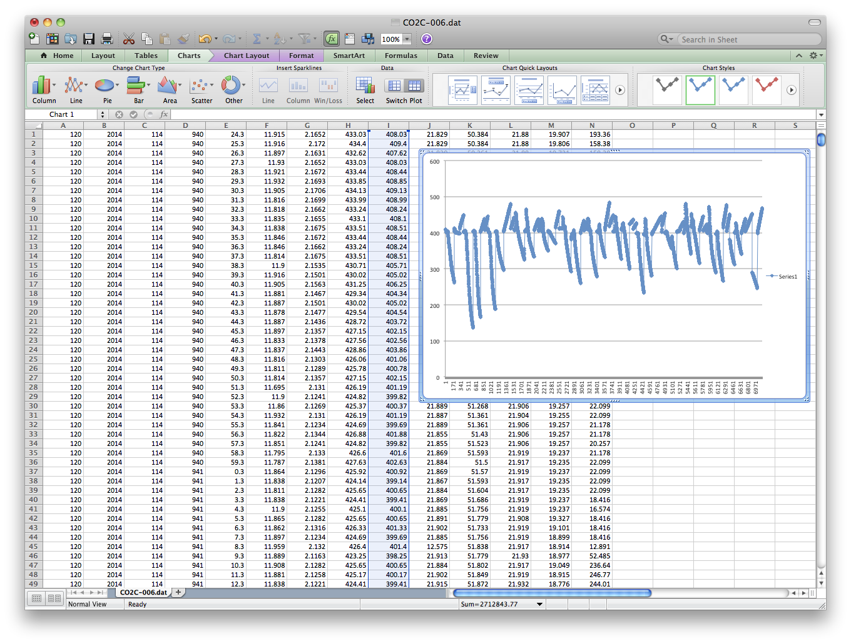A good reading should appear as a steeply increasing linear that has no curve to it.

Data Analysis

1. 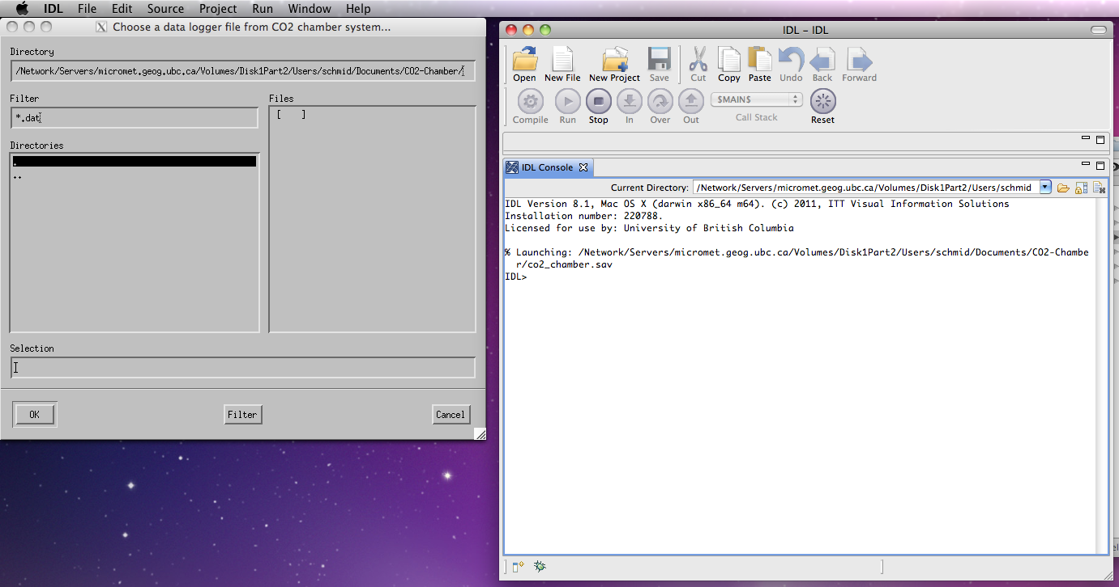Choose CO2 data analysis file (co2_chamber.sav), it will open with IDL Version 8.1
2. Once the window “Choose a data logger file from CO2 chamber system…” appears, use the dots (**.** -> back) (**..** -> open) in the left window to navigate through your folders.

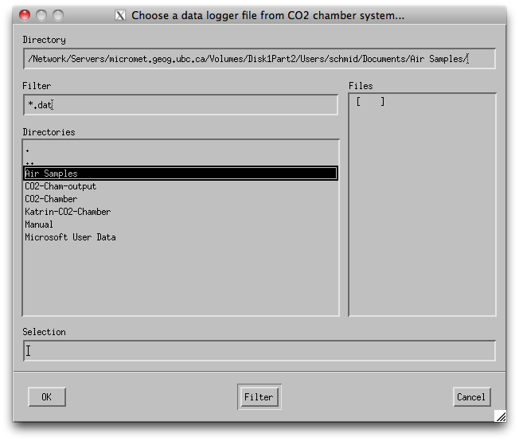

1. 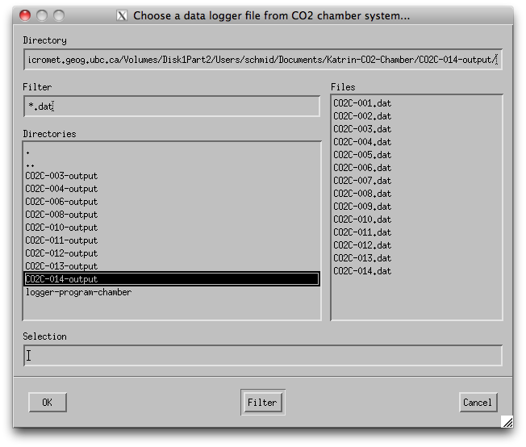Select data file from right window to analyse, press OK.
2. 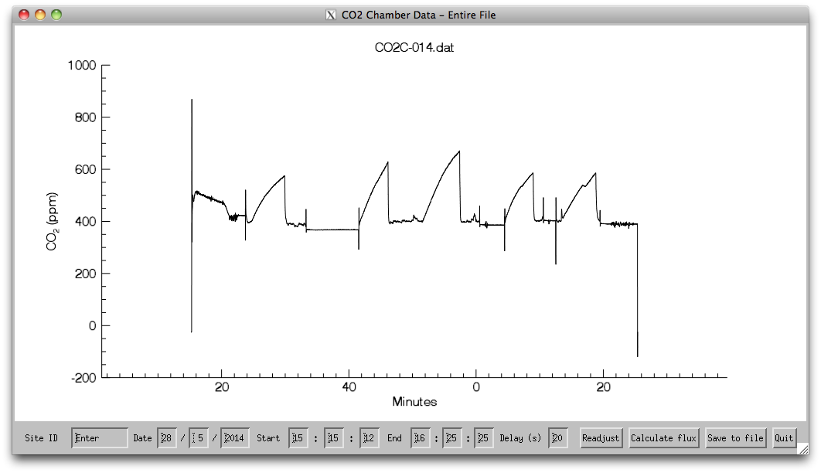A new window will pop up, the graph shown displays data collected over the entire day. Use taskbar at bottom of window to enter information related to current sampling. Data file name (Site ID) will be shown above the graph.
3. 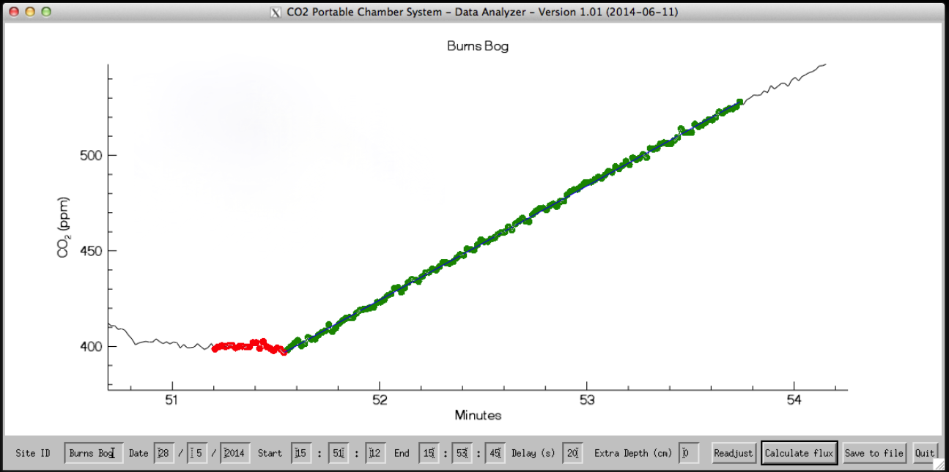To zoom in on one sampling, adjust start and end times on bottom taskbar. Set “Delay” (displayed by red markers on graph) to 20s or until red markings reach base of linear. After changing information on taskbar, click “Readjust
4. 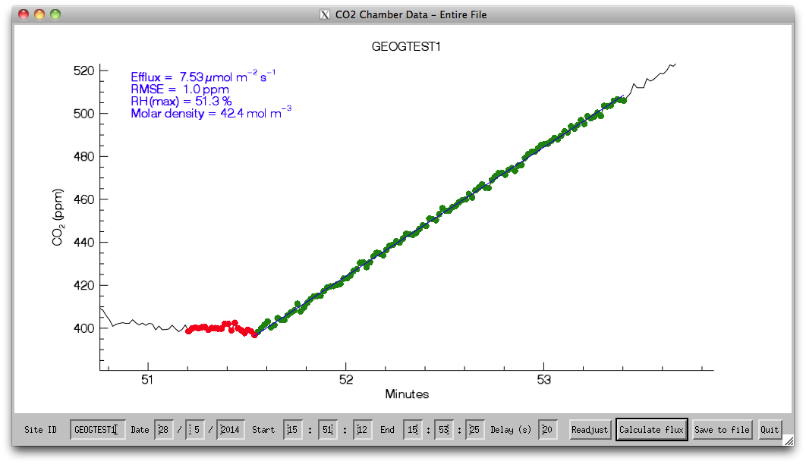After identifing pertinent section of graph (highlighted by green markers), choose “Calculate flux”. A blue line drawn through the green markers shows the average efflux.
5. Efflux, RMSE, RH(max) and Molar density values will be displayed in top left corner of graph.
6. **Efflux value should not exceed 20μmol m-2 s-1**
7. **RMSE = estimated Error for blue flux linear; should not exceed 2ppm**
8. **RH(max) should not exceed 95%**
9. **Molar density of air should be ~40mol m-3**
10. Save to file. -> File will be saved in “(…)output” folder.

1. Take care to avoid sucking water directly into the lines. This will cause immediate measurement problems and require thorough drying and costly repair.